**Update the System Packages**

Log in to your Ubuntu instance via SSH and update the package lists:

sudo apt update && sudo apt upgrade -y

### ****2. Install Required Dependencies****

Docker requires a few prerequisite packages. Install them using:

sudo apt install -y apt-transport-https ca-certificates curl software-properties-common

### ****Add Docker’s Official GPG Key****

Import Docker's GPG key:

curl -fsSL https://download.docker.com/linux/ubuntu/gpg | sudo gpg --dearmor -o /usr/share/keyrings/docker-archive-keyring.gpg

### ****Add the Docker Repository****

Add the Docker repository to your package sources:

echo "deb [arch=$(dpkg --print-architecture) signed-by=/usr/share/keyrings/docker-archive-keyring.gpg] https://download.docker.com/linux/ubuntu $(lsb_release -cs) stable" | sudo tee /etc/apt/sources.list.d/docker.list > /dev/null

### ****Install Docker Engine****

1. Update the package lists to include the new Docker repository:

sudo apt update

1. Install Docker:

sudo apt install -y docker-ce docker-ce-cli containerd.io

### ****Verify Docker Installation****

1. Check Docker version:

docker -–version

Verify that Docker is running:

sudo systemctl status docker

### ****Manage Docker as a Non-Root User (Optional)****

To use Docker without sudo, add your user to the docker group:

sudo usermod -aG docker $USER

Apply the changes by logging out and logging back in, or use:

newgrp docker

**GIT installation**

sudo apt install -y git

Maven Installation

sudo apt install maven -y

Java installation

sudo apt install -y openjdk-17-jdk

sudo update-alternatives --config java

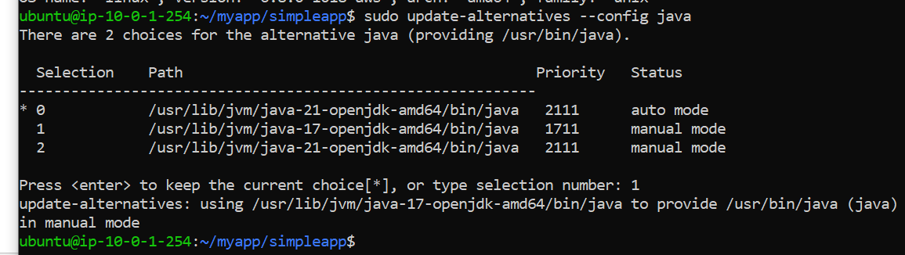

By default maven uses java 21 so abv command to override 17

Install Docker Compose

**Download the Docker Compose Binary:**

sudo curl -L "https://github.com/docker/compose/releases/download/v2.22.0/docker-compose-$(uname -s)-$(uname -m)" -o /usr/local/bin/docker-compose

Verify the Installation:

docker-compose –version

To enable permission for docker-compose to run

### sudo chmod +x /usr/local/bin/docker-compose

### mvn package -DskipTests